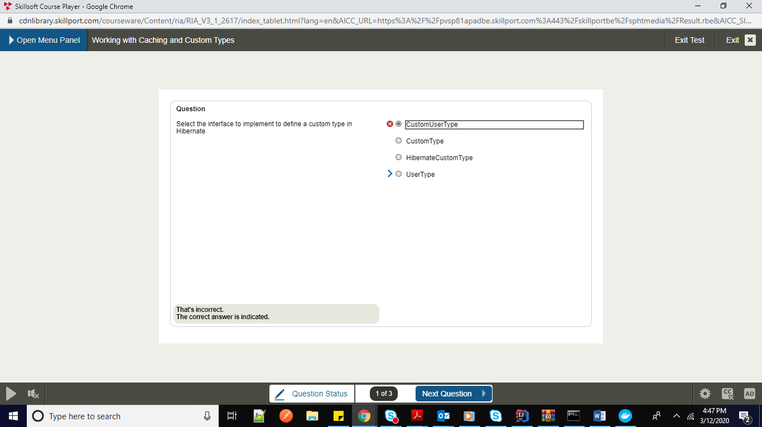

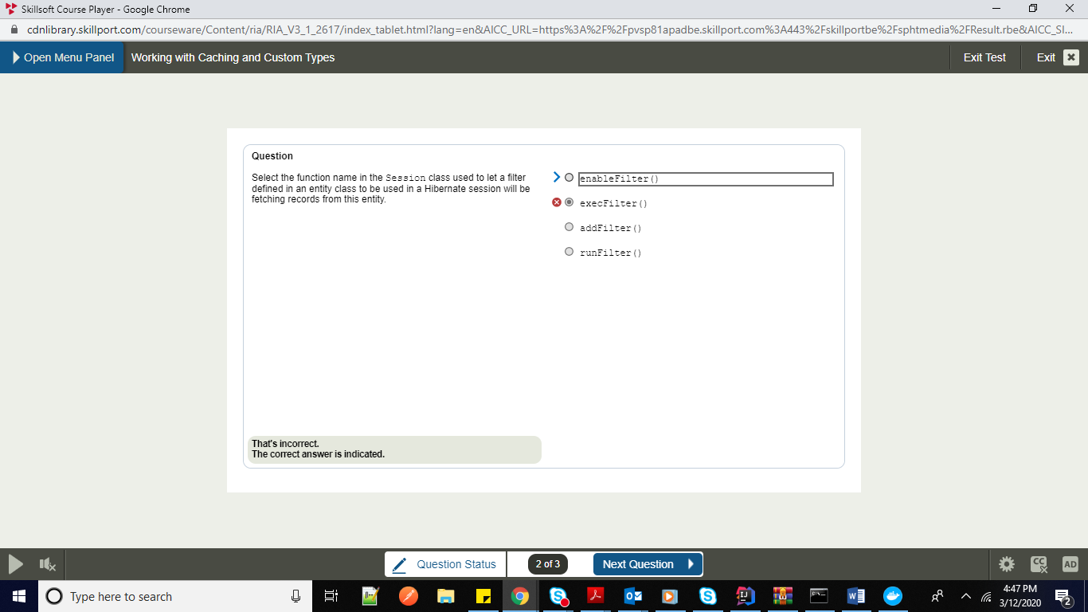

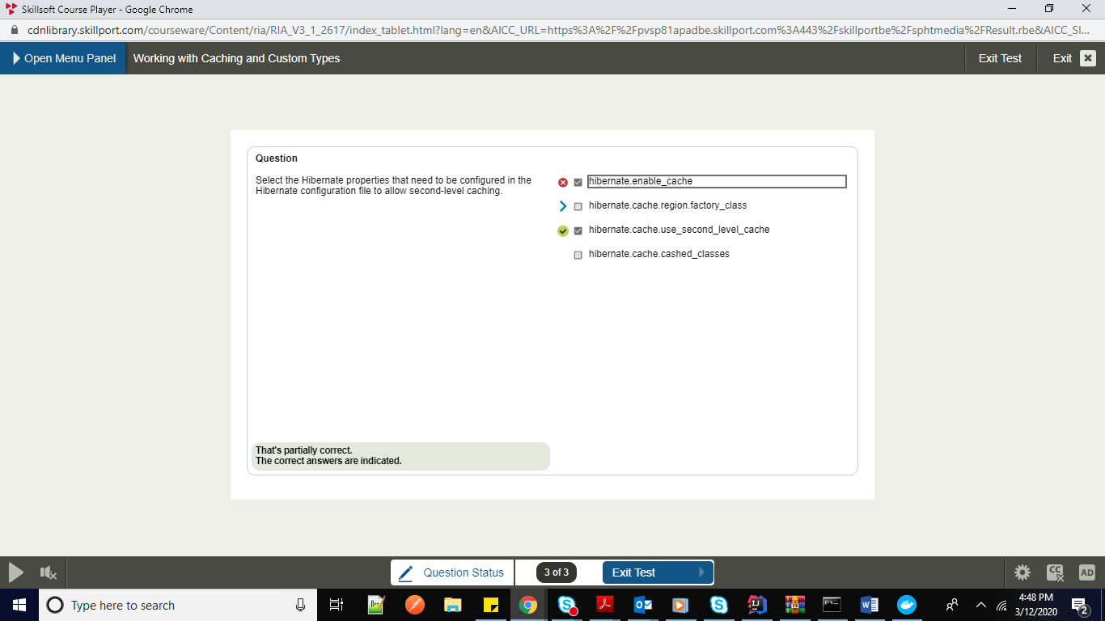

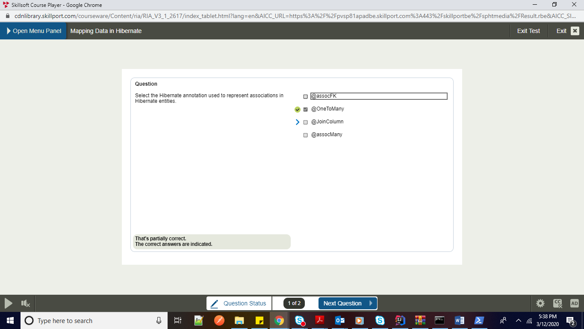

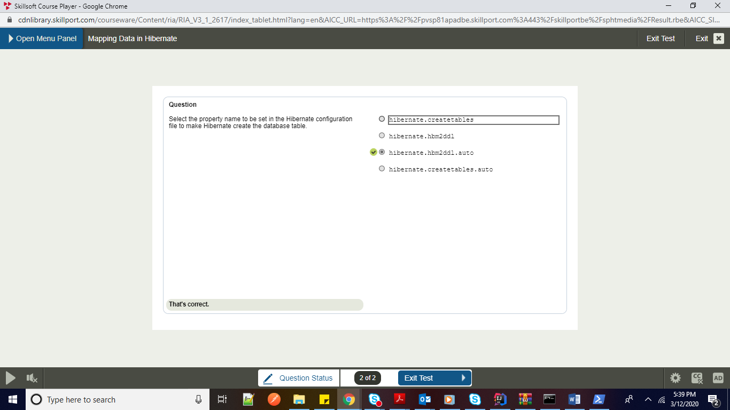

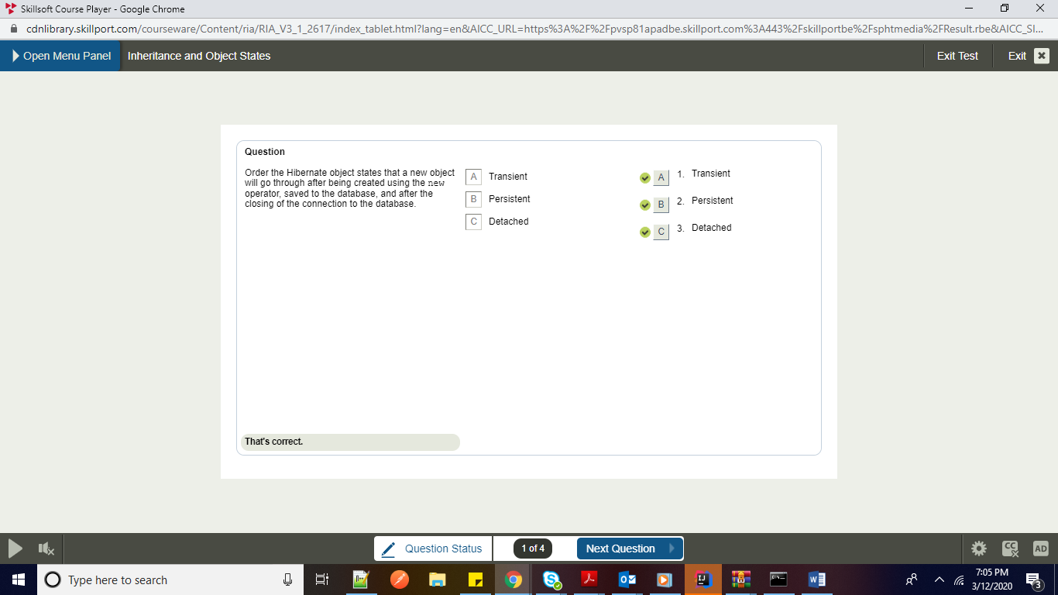

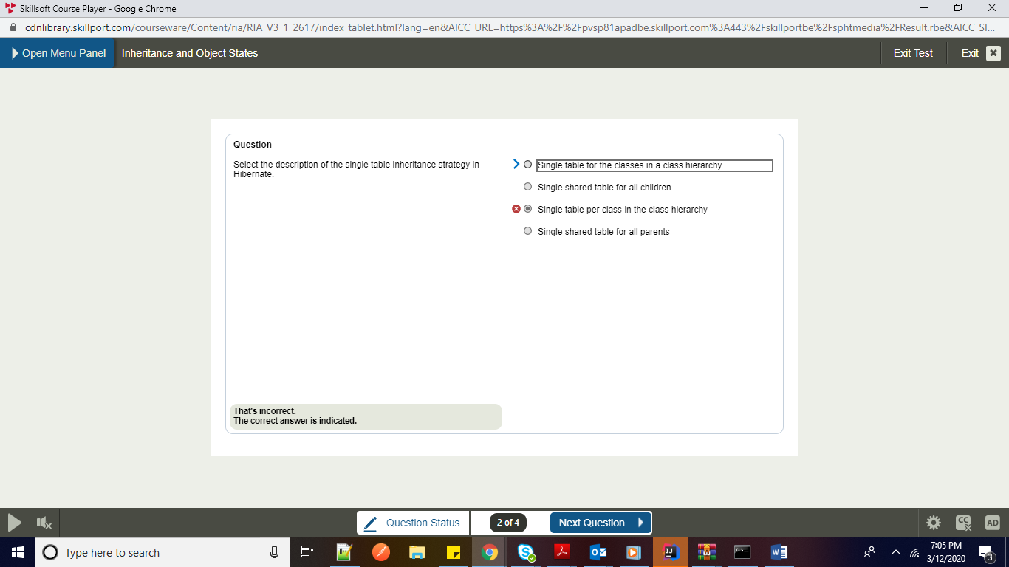

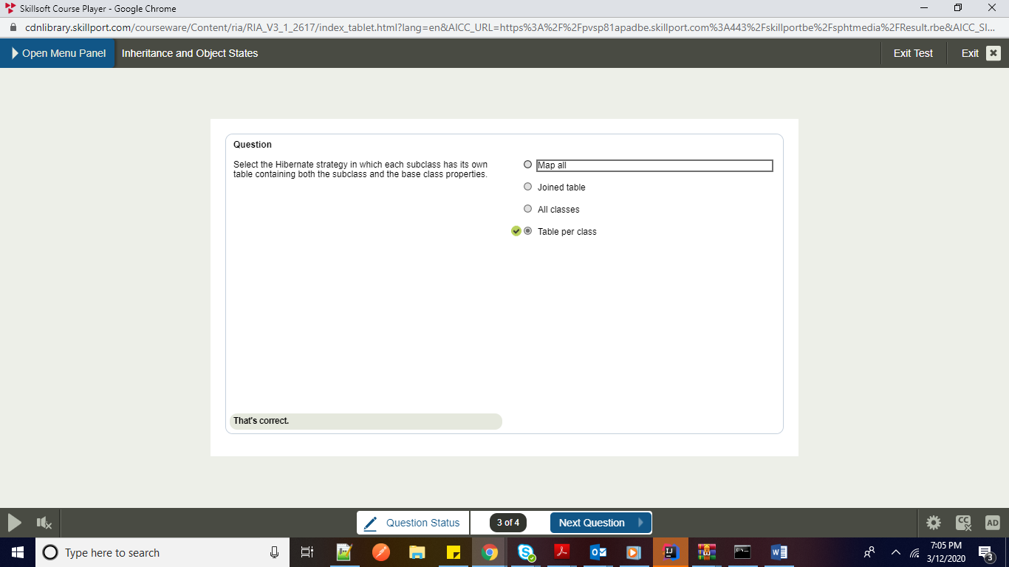

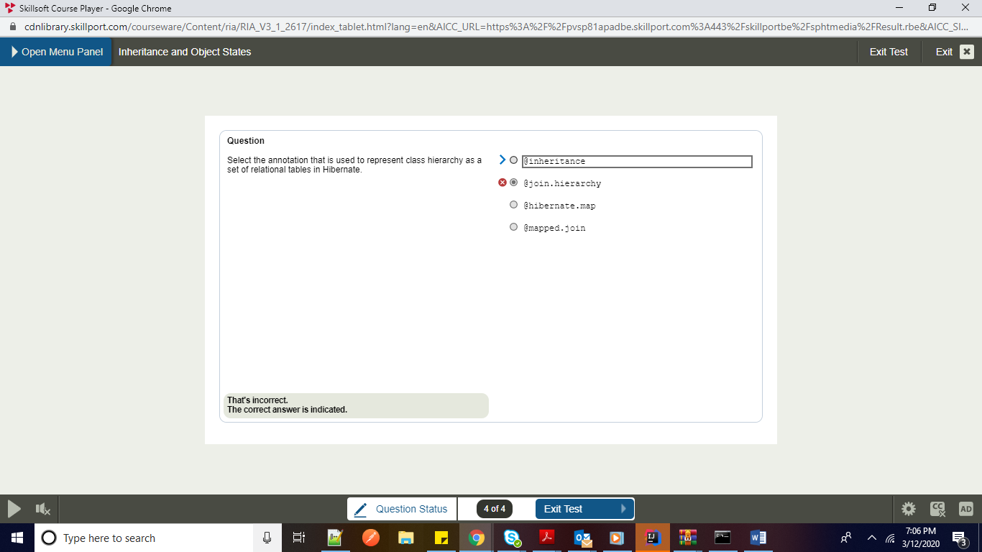Code Notes:-

ICU4J:- Globalization support

JUL to SLF4J: Java util logging

JCL over SLF4J

A StatsD client library implemented in Java. Allows for Java applications to easily communicate with statsd.

We need to add Cachebuster configuration

make Transactions-->readonly=true

Transactions should always be in service layer

Dont use DriverManager Datasource

use SessionFactory and Entity manager directly in dao

Parellelism :- Divide and conquer

Router Function:- This concept was introduced in Spring 5

These are helper functions

Router function route will have the implemetation of Rest Endpoint

Spring MVC style Router Functions.

From request you can create response using Builder pattern. You can see all the routes in sinlge place

Spring MVC:- Annotation based

Router 5: Function based

Mono: Single data stream

Flux: Multiple data dstream

Webclient is the new API which spring has introduced which is similar to rest client

To retreive the data from FLux you need to subscribe.

You need to use webclient here not restClient because RestClient doesnot support flux out of the box

Webclient is a replacement of RestTemplate for Flux or stream processigs

WE did both server side and client side coding

Iterator is pull based and reactive streams are push based

Reactive Streams Publisher Subscriber. Flux and Mono Webclient is reactive spring. Router Funcations in Spring 5

To support Reactive programming flows concept was inroduced in Java 9

Nothing happens until you subscribe. BackPressure is the ability consumer to notify the producer that rate of emission is too high.

Callback Hell. Callback calling another callback

The raw material pours from a source (the original Publisher) and ends up as a finished product ready to be pushed to the consumer (or Subscriber).

Raw Material Publisher, Finalized Product Subscriber

Two broad category of reactive sequences : HOT And COLD

Cold sequences starts a new for each subscriber, A hot sequence does not start a new for each subscribe

FLux: It represents a reactive sequence of 0 to N items

Mono: It represents a reactive sequence of 0 to 1 item

For instance, an HTTP request produces only one response, so there is not much sense in doing a count operation. Expressing the result of such an HTTP call as a Mono<HttpResponse> thus makes more sense than expressing it as a Flux<HttpResponse>

A flux is terminated by a completion Signal or an error

To downsream subscriber onNext(), onEvent() and onError() method

Mono<Void> is just similar to runnalbeNote that you can use a Mono to represent no-value asynchronous processes that only have the concept of completion (similar to a Runnable). To create one, you can use an empty Mono<Void>

Cancelling a subscribe() with Its Disposabl

This cancel-and-clean-up behavior is represented in Reactor by the general-purpose Disposable interface.

Reactive programming:- Asynchornous data streams

Programming reactiing on events is called Reactive programming

Netflix uses Reactive. Netflix Rx Java Netflix API.(2014)

Reactive Systems:

1. Responsive

2. Resilient

3. Elastic

Iterable and observable design pattern

Observable is when we push the data. Server side

Iterable pull

Observable push

onCompleted and onError() are terminal statements

Promises are used as a substitute of callback function

callback function, means function inside a function

eg. students.forEach()

SetTimeout is always a callback function

enroll Student callback ko wait karayega, use pakadkar rakhega

Await function pause kar dega function ki execution ko until promise is fulfilled.

Without async and await to fetch an API in javascript you need to use .then() 2 times (twice)

Response.json also returns a promise only

Async alwasy returns promise

Await pause kar deta hai jab tak promise nahin fulfill hota

Await temporarilty doosre kamon ke liye bhej deta hai

Async men poora function ek promise return karta hai

XHR: XML Httprequest X

Vanilla javascript: Pura Javascript without any framework or library

=================================

Mulesoft:-

Munit

Integration framework, lightweight

ESB Easy to integrate third party applications

Core Principles of ESB:-

1.Trasnportation: Transport protocols JMS JDBC HTTP

2. Orchestration

3. Mediation:- It enables different channels Support backword compatibility

4. Tranformation :- Tranformation of data

5. Non functional consistency :- The way monitoring and security config should be consistency

Mule :-

1. Record Variable:- Batch processing

2. Session variable:- scope is within the applications

3. Flow Variable: scope is within flow

Record variable is used in batch processing

We will merging with batch processing

===========================

Primitives in mediation

Shared context is the context which is present is Service MEssage Object.

Types of Endpoints in Mule:- HTTP, JMS, IMAP, SMTP, and AJAX

Every project might not require ESb. We should analyse this. Certain things:-

1. Integration of more than 3 applicaitons and services.

2. Communitcation between two application : Point to point integration

3. Need to scale the project in future

4. If the project requires message routing ability

5. Clarity of the architecture that needs to be acheived

======================

Mule Flow Sumit Rawal is flow S R F Session Record Flow

SRF session record or flow

Exception Handling in mule esb:-

=======================

Advantages of Mulesoft

1. 3rd party applications easily

2. Integration with systesm or applicaitons easily

3. Connect anything anywhere rather than point to point integration

4. It provides most of security features.

5. Intelligently managing message routing, scalabiliyt reliabilty

-----------------------------------------------

Helps you to connect any 3rd party applicaiotn easily

========================================

Phaser’s primary purpose is to enable synchronization of threads that represent one or more phases of activity. It lets us define a synchronization object that waits until a specific phase has been completed. It then advances to the next phase until that phase concludes. It can also be used to synchronize a single phase, and in that regard, it acts much like a CyclicBarrier.